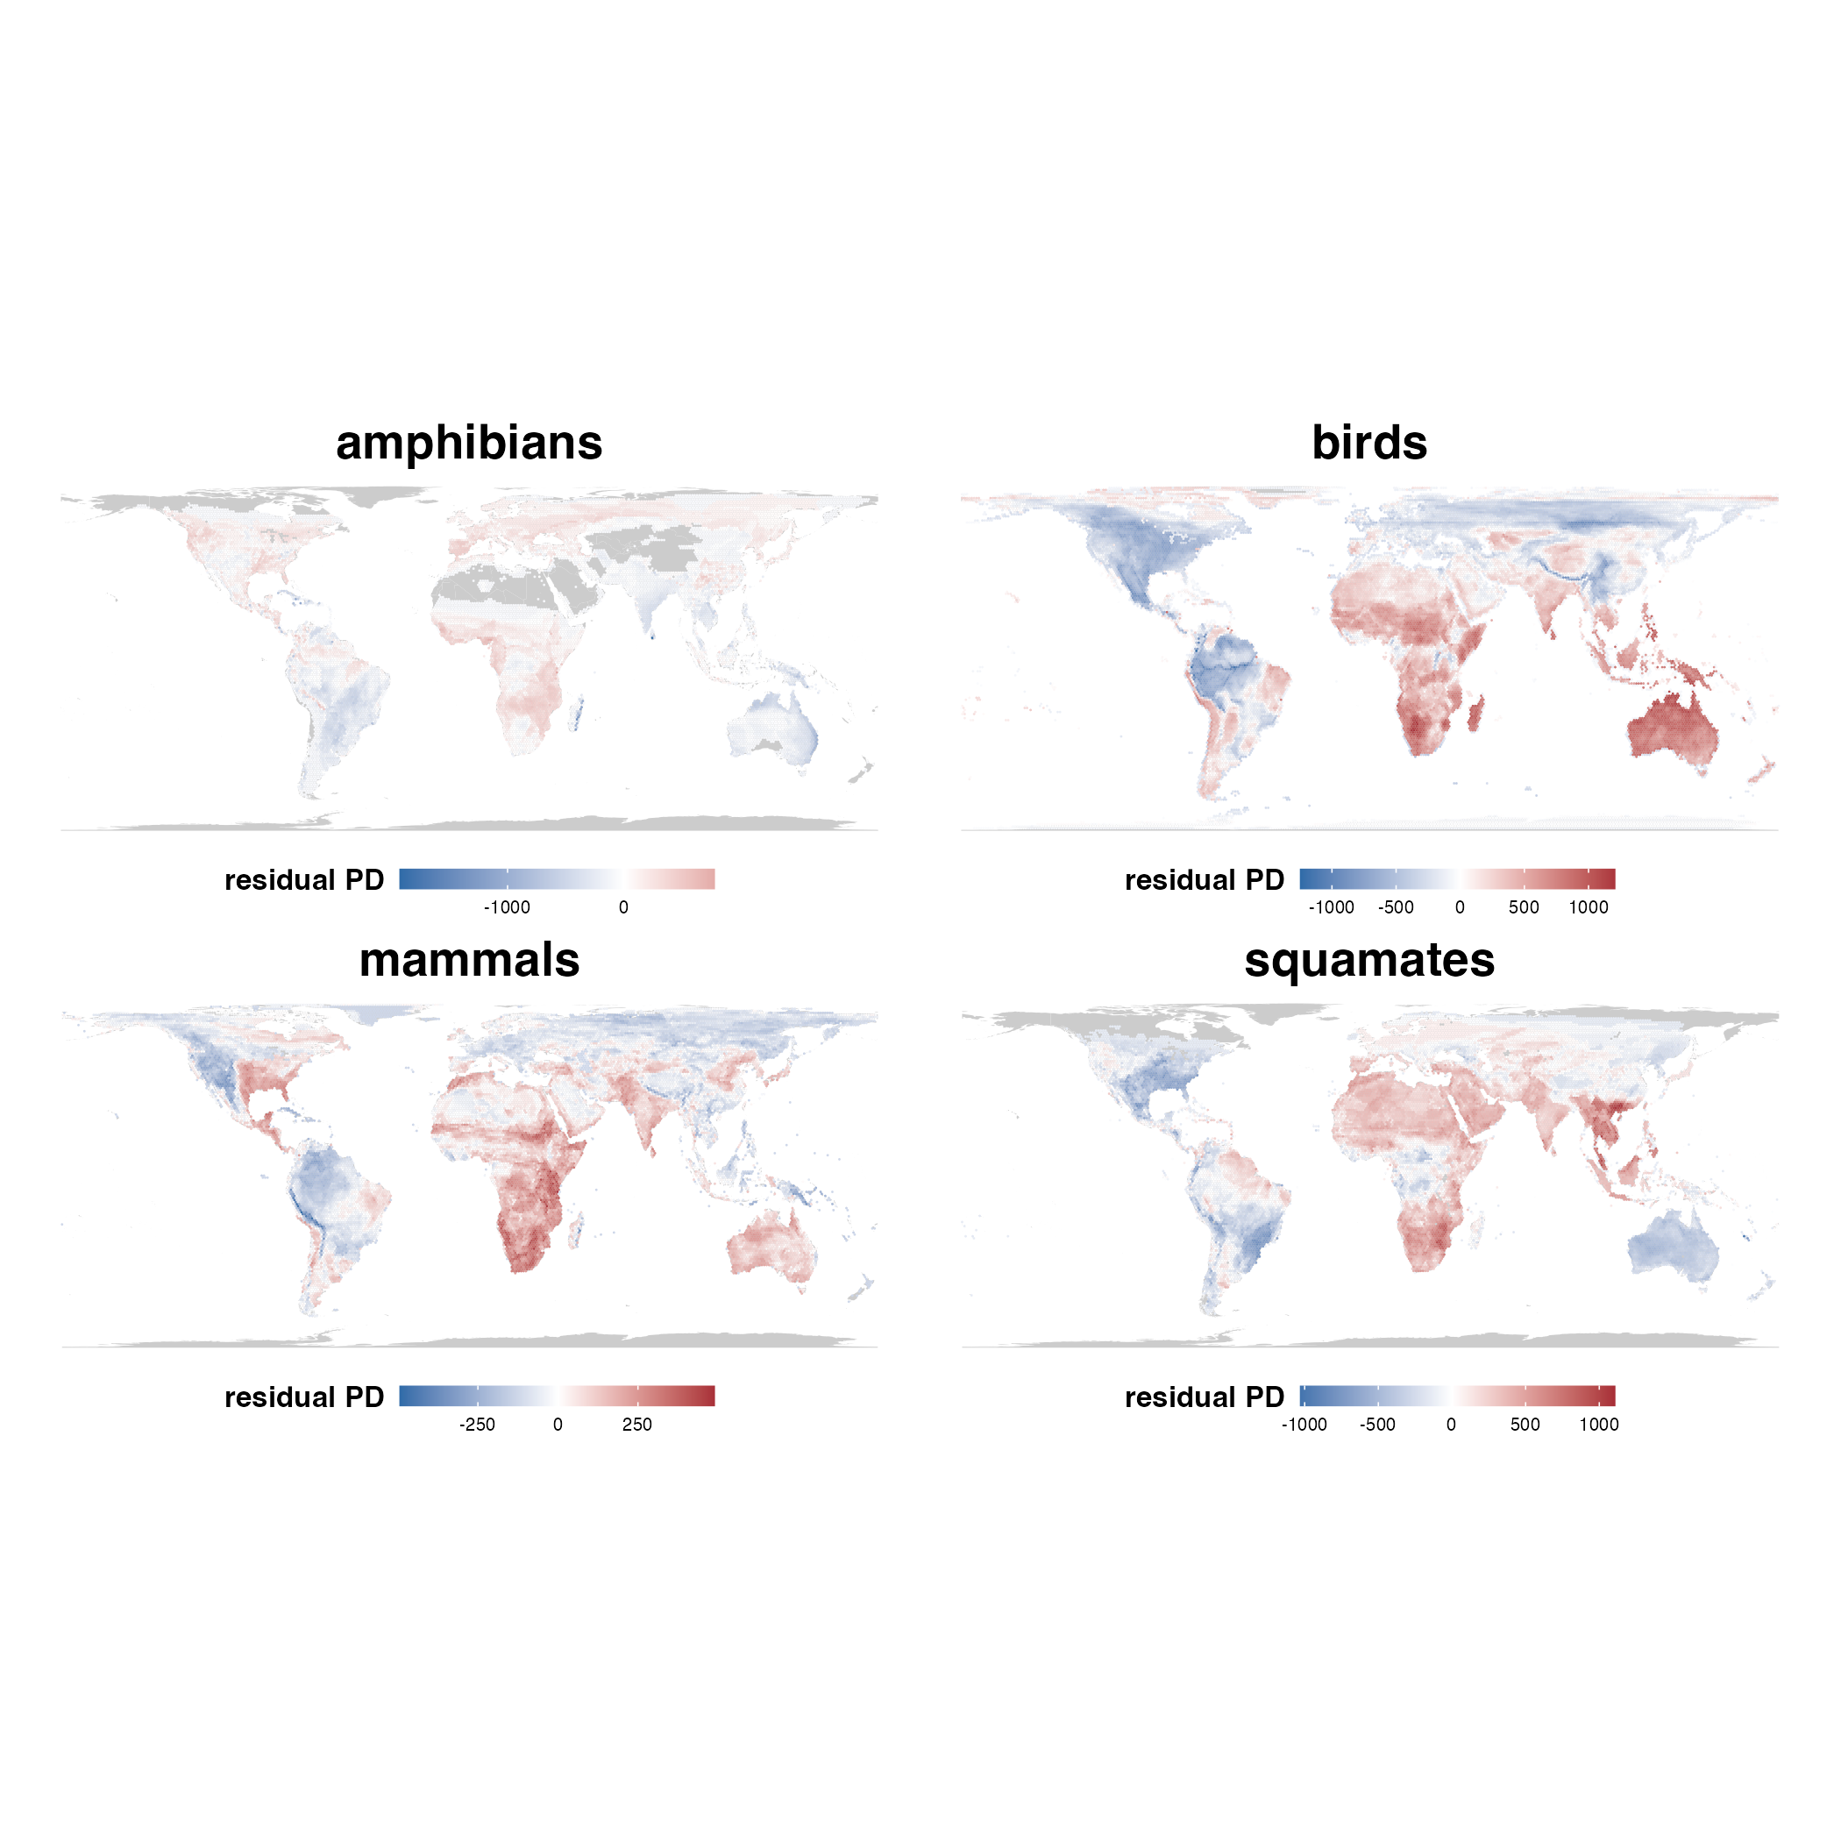

**Supplementary Figure 1**. Maps of residual phylogenetic diversity (PD) for all terrestrial vertebrate clades.

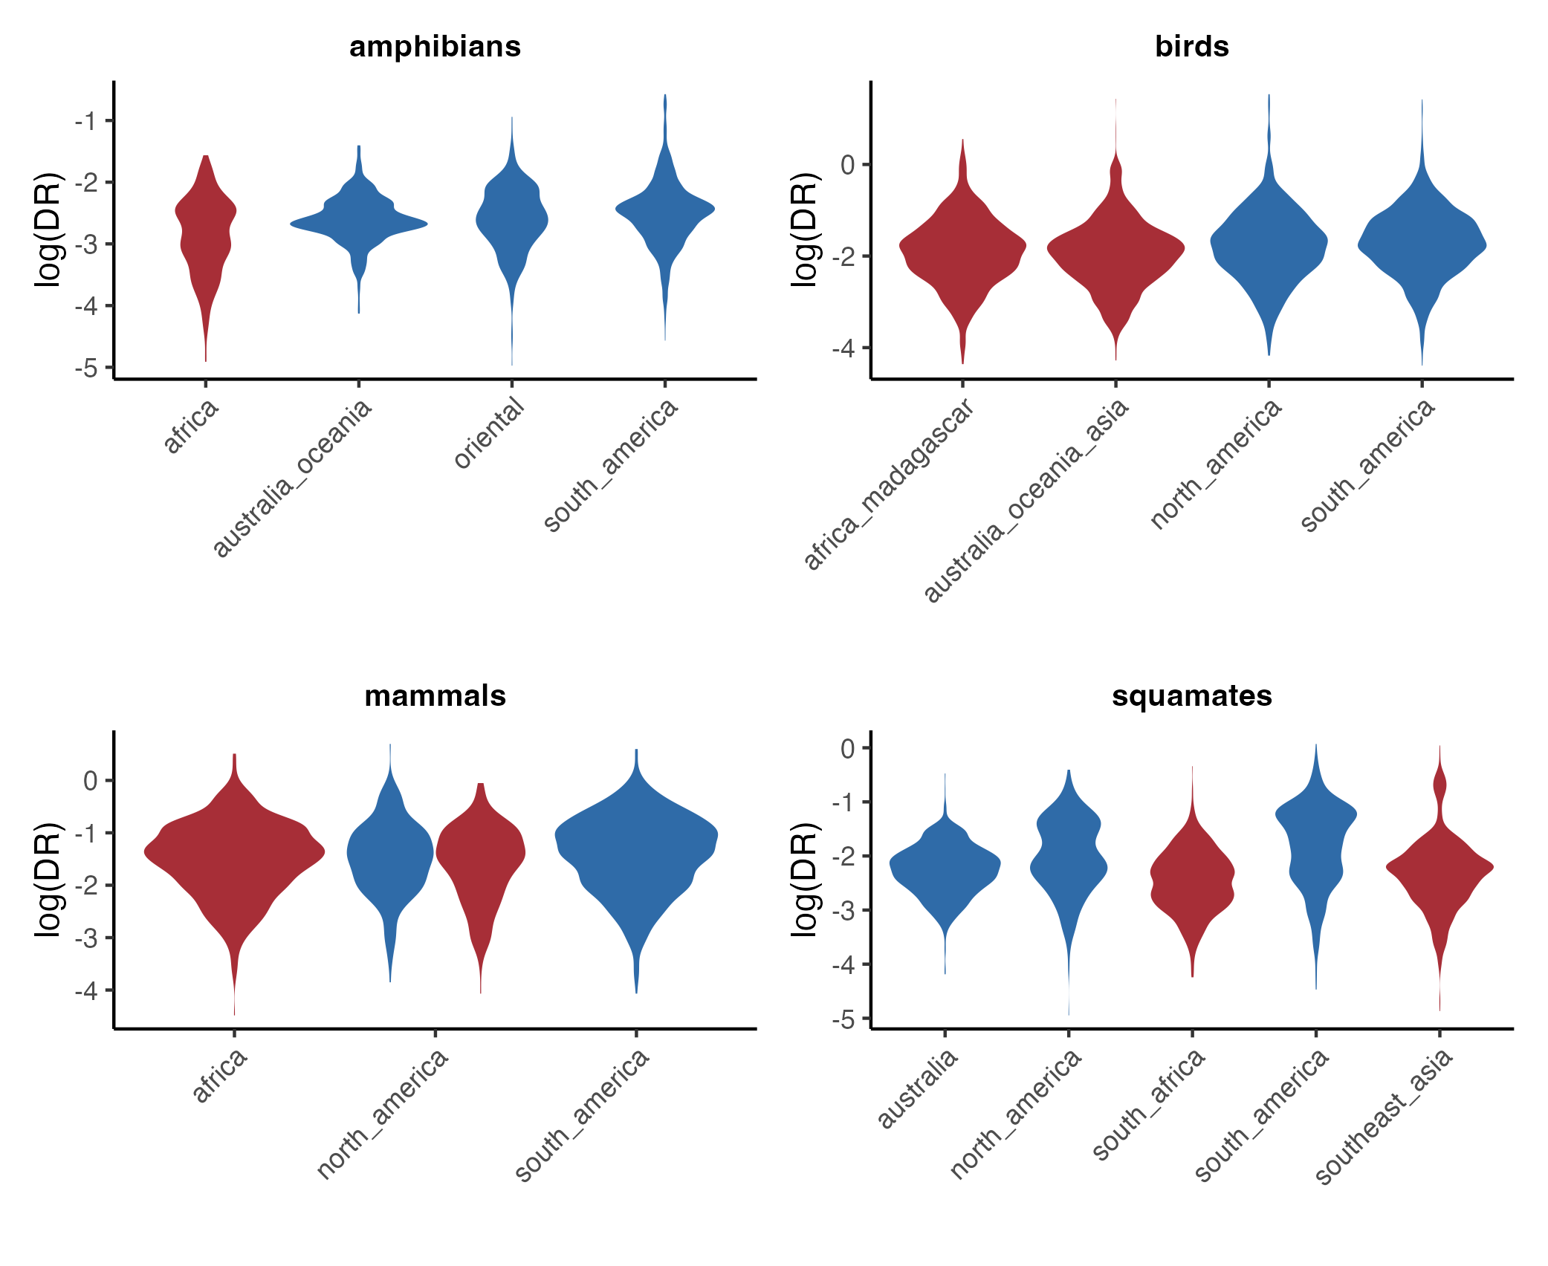

**Supplementary Figure 2**. Violin plots of recent speciation (DR) rates in the different focal areas identified as centers of high and low residual PD for all terrestrial vertebrate clades.



**Supplementary Figure** **3**. Pairwise differences in DR rates (effect size Z) between specific regions of high and low residual PD, colored by taxa group. Left: differences between pairs of regions of low residual PD. Center: differences between regions of high residual PD and regions of low residual PD. Right: differences between pairs of regions of high residual PD.



**Supplementary Figure 4**. Lineage-through-time (LTT) plots for amphibian lineages in the different focal regions of low (in blue) and high (in red) residual PD.



**Supplementary Figure 5**. Lineage-through-time (LTT) plots for bird lineages in the different focal regions of low (in blue) and high (in red) residual PD.



**Supplementary Figure 6**. Lineage-through-time (LTT) plots for mammal lineages in the different focal regions of low (in blue) and high (in red) residual PD.

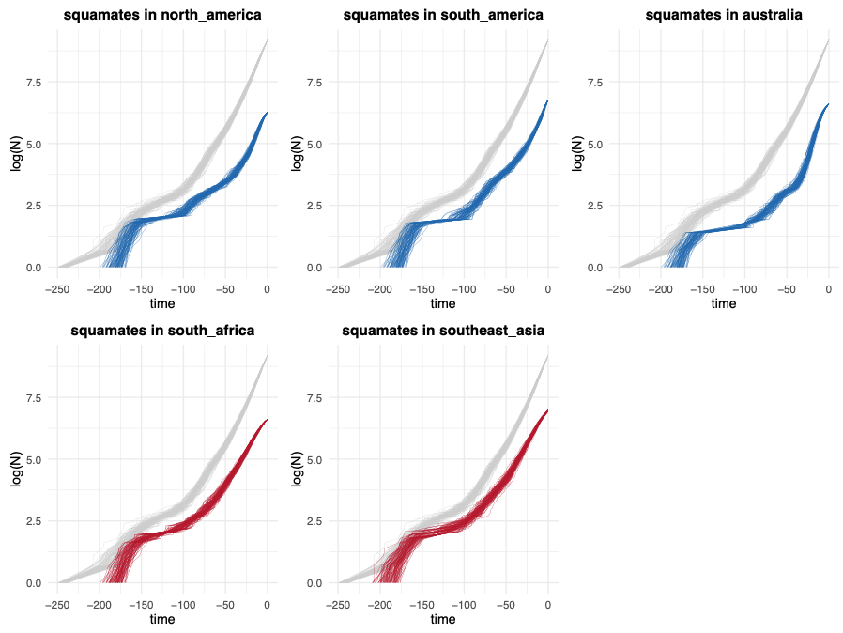

**Supplementary Figure 7**. Lineage-through-time (LTT) plots for squamate lineages in the different focal regions of low (in blue) and high (in red) residual PD.

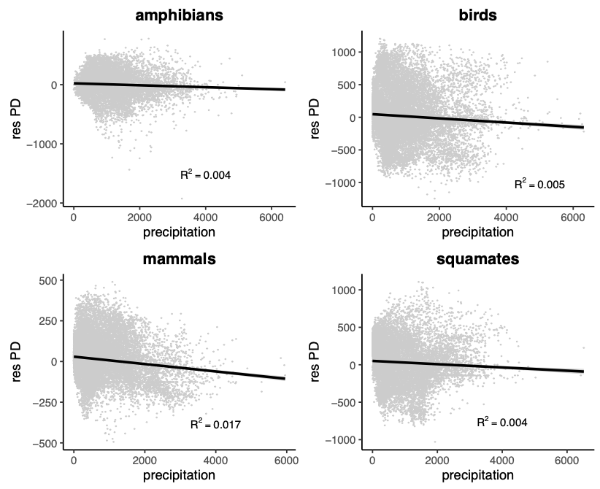

**Supplementary Figure 8**. Relationship of annual precipitation (in mm) with residual PD in all tetrapod clades.

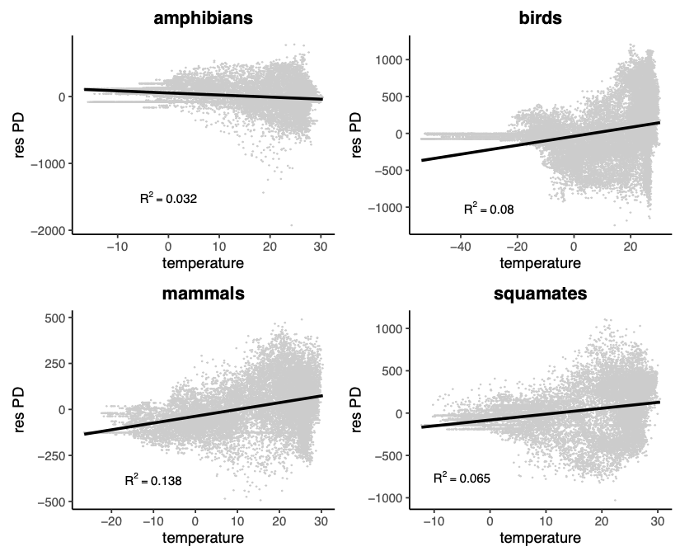

**Supplementary Figure 9**. Relationship of mean temperature (in ºC) with residual PD in all tetrapod clades.

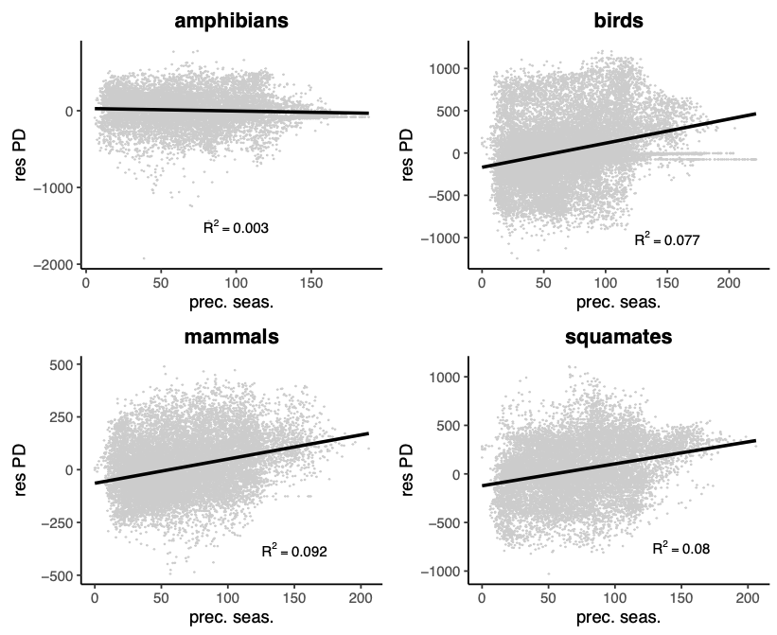

**Supplementary Figure 10**. Relationship of precipitation seasonality and residual PD in all tetrapod clades.

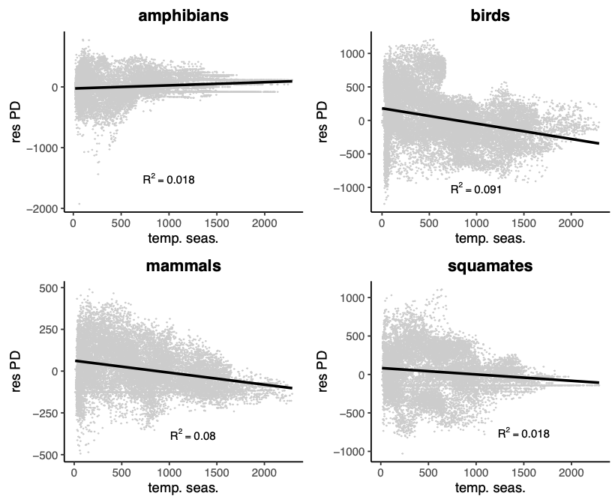

**Supplementary Figure 11**. Relationship of temperature seasonality and residual PD in all tetrapod clades.

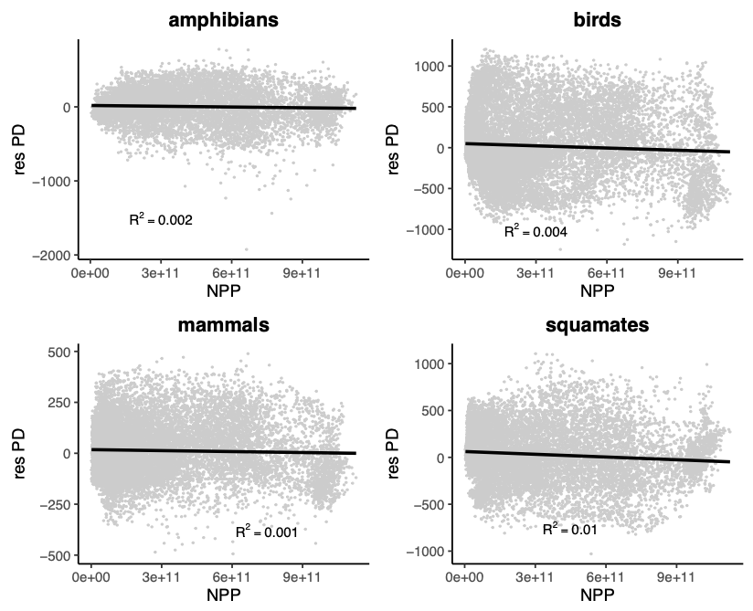

**Supplementary Figure 12**. Relationship of net primary productivity (NPP) and residual PD in all tetrapod clades.

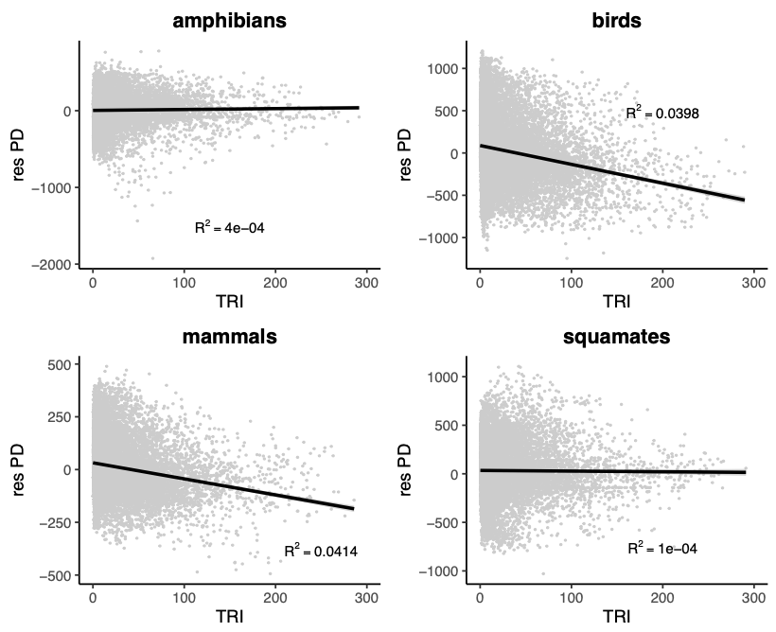

**Supplementary Figure 13**. Relationship of terrain roughness index (TRI; a measurement of topographic complexity) and residual PD in all tetrapod clades.

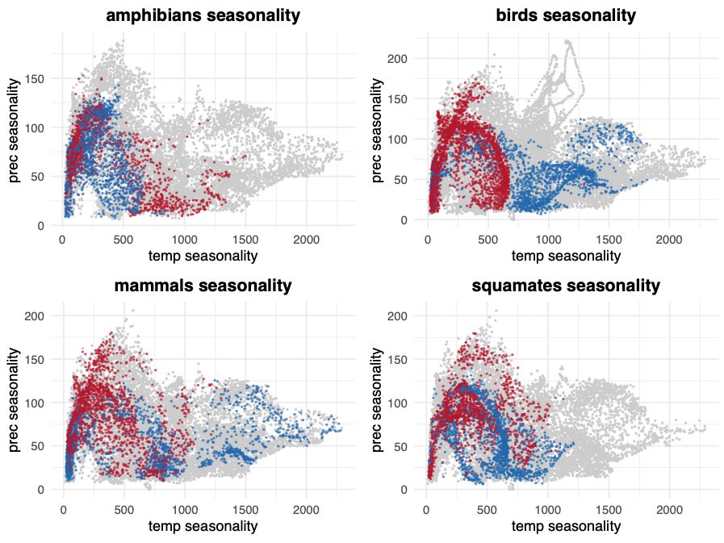

**Supplementary Figure 14**. Climatic space defined by precipitation seasonality and temperature seasonality for all tetrapod clades, showing the geographic grid cells with the 10% lowest (in blue) and highest (in red) residual PD.

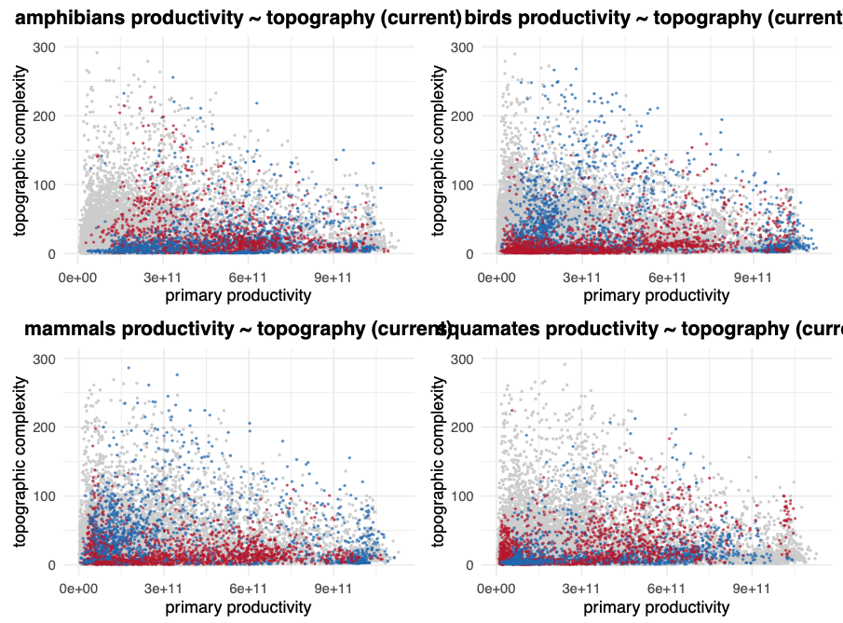

**Supplementary Figure 15**. Climatic space defined by net primary productivity (NPP) and terrain roughness index (TRI) for all tetrapod clades, showing the geographic grid cells with the 10% lowest (in blue) and highest (in red) residual PD.

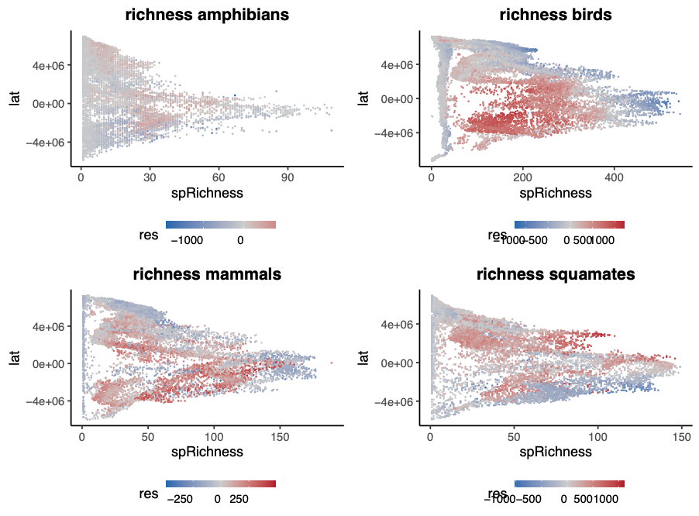

**Supplementary Figure 16**. Latitudinal pattern of species richness (in the X-axis) and residual PD (in the color gradient) for all tetrapod clades.